Topic: New product at Cersaie 2013
Additional information: Reprint free of charge. Specimen copy requested Date: September 2013

Innovation in the shower segment: wedi Solso is the ideal sub-structure for PVC floor coverings

Floor-level showers with a PVC surface are often billed as being suitable for the care industry, workplaces and public buildings. The reason why it's so popular is that PVC is laid as part of a virtually seamless process and is therefore easy to clean as well as being hygienic. New surfaces and visual diversity also mean that PVC is currently celebrating a comeback. And it's being used to practically implement these showers: Screed layers are always confronted with the task of having to create a completely even surface, while installers are asking how they can fit the drain in such a way to make it watertight. wedi has solved these problems and developed an entirely new generation of floor-level shower elements. Indeed, wedi Solso is the ideal sub-structure for shower systems featuring modern PVC coatings.
With wedi Solso, the Emsdetten-based company is heading down an entirely new path from 2014. That's because the remit of developing a floor-level sub-structure for PVC floor coverings involves altogether different requirements with respect to the load-bearing capacity and how it is distributed over the shower's entire sub-structure. The developers at wedi also deal with the issue of channelling off moisture, such as the dispersion adhesives used in laying PVC coatings, or how to easily and reliably seal the PVC in the drain area.
New material exclusive to wedi Solso
To satisfy all of these requirements, wedi has used a new material exclusive to Solso as a foundation material: extremely durable, highly compressed expanded polystyrene rigid foam (EPS) featuring a special coating reinforced with fibre glass.
System reliability
The PVC is reliably sealed in the drain area by applying the principle of adhesive-free pressing. This means that with wedi Solso, a seal was already fitted into the drain pot's plastic frame in the factory. This prevents water from building up under the PVC and subsequently causing damage. Solso shower elements, including the PVC sealing layer, are therefore systematically watertight. wedi has given its word to this effect in the form of the warranty promise.
Fast and reliable assembly
Solso is 40 millimetres tall and – like all wedi shower elements – is supplied with a surface slope that was precisely and evenly designed in the factory. In this way, installers can build on a completely even surface. The installation steps on the construction site are essentially the same as for the popular and proven Fundo elements. The only extra requirement is the screed being connected to the 2C potting resin, floor compound or similar material.
The process of creating a shower system for installation underneath PVC is rapid and reliable process with wedi Solso. And this also holds true even in barrier-free areas, as Solso is suitable for wheelchair loading without the need to take further reinforcement measures when used in conjunction with suitable PVC.

From 2014, wedi Solso will be available in the sizes 900 x 900 millimetres or 1,200 x 1,200 millimetres, with a horizontal or vertical DN 50 drain and screwable stainless steel cover.

0,000 characters (including spaces)

Images

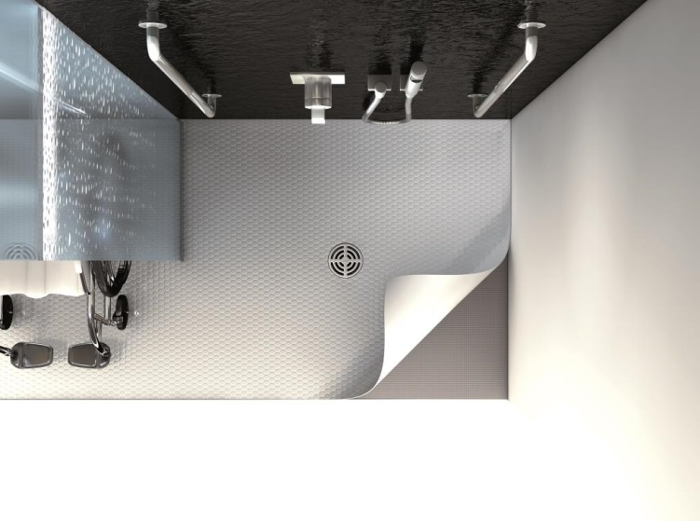

Press contact
Stephanie Hesse
wedi GmbH
Hollefeldstr. 51
48282 Emsdetten
Tel.: +49 2572 156-144
Fax: +49 2572 156-160
stephanie.hesse@wedi.de

